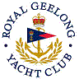 | Royal Geelong Yacht Club Inc.  Est 1859
Trophy Deed of Gift.

Trophy: | Billiards Tournament
Presented by: | Chick Fleet / Reg White
Date: | 1933
For: | Annual Billiards Competition
Remarks / Revisions | Shield  Not Awarded

